Parcel 203

Union Valley Rd, Town of Hinsdale

|  |  |  |  |  |
| --- | --- | --- | --- | --- |
| *No Photo Available* | | **Status:** | Active | |
| **Roll Section:** | Taxable | |
| **Swis:** | 044600 | |
| **Tax Map ID #:** | 85.002-2-25.1 | |
| **Account #:** | 0242 | |
| **Property Class:** | 322 - Rural vac>10 | |
| **Site:** | RES 1 | |
| **In Ag. District:** | No | |
| **Site Property Class:** | 322 - Rural vac>10 | |
| **Zoning Code:** | - | |
| **Neighborhood Code:** | 46100 - Town Roads | |
| **Total Acreage/Size:** | 25.21 | **School District:** | Hinsdale | |
| **Land Assessment:** | 2016 - $18,400 | **Total Assessment:** | 2016 - $18,400 | |
| **Full Market Value:** | 2016 - $20,909 |  |  | |
|  |  |  |  |

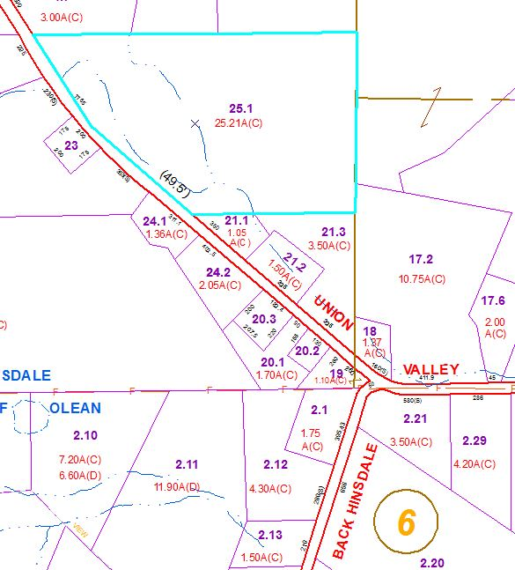

Approximate Yearly Taxes

School $313

Town/County $432

Total $745