Parcel 212

1181 Congress Rd, Town of Hinsdale

|  |  |  |  |  |  |  |  |  |  |  |  |  |  |
| --- | --- | --- | --- | --- | --- | --- | --- | --- | --- | --- | --- | --- | --- |
| http://maps.cattco.org/Imate/quickstream.aspx?file=VOLLOCAL/Rel2016/044600077001000103700000000004.jpg&thumb=true&width=201&height=152 | | | | | | | **Status:** | | | Active | | | |
| **Roll Section:** | | | Taxable | | | |
| **Swis:** | | | 044600 | | | |
| **Tax Map ID #:** | | | 77.001-1-37 | | | |
| **Account #:** | | | 0763 | | | |
| **Property Class:** | | | 210 - 1 Family Res | | | |
| **Site:** | | | RES 1 | | | |
| **In Ag. District:** | | | No | | | |
| **Site Property Class:** | | | 210 - 1 Family Res | | | |
| **Zoning Code:** | | | - | | | |
| **Neighborhood Code:** | | | 46100 - Town Roads | | | |
| **Total Acreage/Size:** | | | 1.45 | | | | **School District:** | | | Hinsdale | | | |
| **Land Assessment:** | | | 2016 - $8,400 | | | | **Total Assessment:** | | | 2016 - $20,000 | | | |
| **Full Market Value:** | | | 2016 - $22,727 | | | |  | | |  | | |
| **Living Area:** | | 1,399 sq. ft. | | | **First Story Area:** | | | 960 sq. ft. | | | |
| **Additional Story Area:** | | 0 sq. ft. | | | **3/4 Story Area:** | | | 439 sq. ft. | | | |
| **Finished Basement:** | | 0 sq. ft. | | | **Number of Stories:** | | | 1.7 | | | |
| **Building Style:** | | Old style | | | **Bathrooms Full:** | | | 1 | | | |
| **Bedrooms:** | | 3 | | | **Kitchens:** | | | 1 | | | |
| **Fireplaces:** | | 0 | | | **Basement Type:** | | | Partial | | | |
| **Porch Type:** | | Porch-covered | | | **Porch Area:** | | | 213.00 | | | |
| **Overall Condition:** | | Poor | | | **Overall Grade:** | | | Minimum | | | |
| **Year Built:** | | 1900 | | |  | | |  | | | |
| **Structure** | **Size** | | | **Grade** | | **Condition** | | | **Year** | |  | | | |
| Shed-machine | 14 × 20 | | | Economy | | Poor | | | 1930 | |  | | | |
| Porch-covered | 213 sq. ft. | | | Minimum | | Poor | | | 1900 | |  | | | |

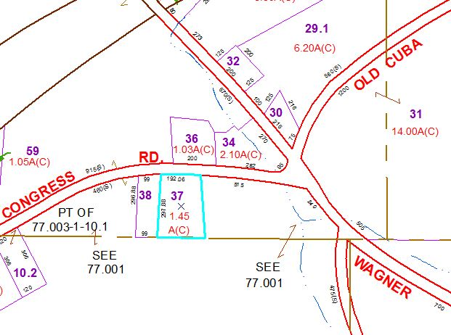

Approximate Yearly Taxes

School $340

Town/County $470

Total $810