Parcel 87

179 Hillside Dr, Town of Carrollton

|  |  |  |  |  |  |  |  |  |  |  |  |  |  |  |
| --- | --- | --- | --- | --- | --- | --- | --- | --- | --- | --- | --- | --- | --- | --- |
| http://maps.cattco.org/Imate/quickstream.aspx?file=VOLLOCAL/Rel2016/042400110001000200600000000004.jpg&thumb=true&width=201&height=152 | | | | | | | **Status:** | | | | Active | | | |
| **Roll Section:** | | | | Taxable | | | |
| **Swis:** | | | | 042400 | | | |
| **Tax Map ID #:** | | | | 110.001-2-6 | | | |
| **Account #:** | | | | 0322 | | | |
| **Property Class:** | | | | 210 - 1 Family Res | | | |
| **Site:** | | | | RES 1 | | | |
| **In Ag. District:** | | | | No | | | |
| **Site Property Class:** | | | | 210 - 1 Family Res | | | |
| **Zoning Code:** | | | | 01 | | | |
| **Neighborhood Code:** | | | | 24050 | | | |
| **Total Acreage/Size:** | | | 85 x 90 | | | | **School District:** | | | | Allegany - Limestone | | | |
| **Land Assessment:** | | | 2016 - $3,500 | | | | **Total Assessment:** | | | | 2016 - $10,000 | | | |
| **Full Market Value:** | | | 2016 - $11,494 | | | |  | | | |  | | |
| **Living Area:** | | 1,729 sq. ft. | | | **First Story Area:** | | | | | 988 sq. ft. | | |
| **Additional Story Area:** | | 0 sq. ft. | | | **3/4 Story Area:** | | | | | 741 sq. ft. | | |
| **Finished Basement:** | | 0 sq. ft. | | | **Number of Stories:** | | | | | 1.7 | | |
| **Building Style:** | | Old style | | | **Bathrooms (Full - Half):** | | | | | 1 - 0 | | |
| **Bedrooms:** | | 6 | | | **Kitchens:** | | | | | 1 | | |
| **Fireplaces:** | | 0 | | | **Basement Type:** | | | | | Partial | | |
| **Porch Type:** | | Porch-enclosed | | | **Porch Area:** | | | | | 70.00 | | |
| **Basement Garage Cap:** | | 1 | | | **Attached Garage Cap:** | | | | | 0.00 sq. ft. | | |
| **Overall Condition:** | | Poor | | | **Overall Grade:** | | | | | Average | | |
| **Year Built:** | | 1940 | | |  | | | |  | | | |
| **Structure** | **Size** | | | **Grade** | | **Condition** | | **Year** | | | |  | | | |
| Porch-enclosed | 10 × 7 | | | Average | | Normal | | 1940 | | | |  | | | |
| Porch-enclosed | 7 × 6 | | | Average | | Normal | | 1940 | | | |  | | | |
| Porch-covered | 128 sq. ft. | | | Average | | Normal | | 1940 | | | |  | | | |

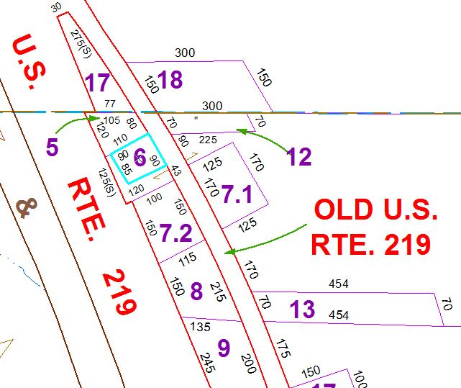

Approximate Yearly Taxes

School $212

Town/County $202

Total $414

|  |  |  |  |
| --- | --- | --- | --- |
|  |  |  |  |