Parcel 130

320 Parkside Dr., Town of Carrollton

|  |  |  |  |  |
| --- | --- | --- | --- | --- |
| *No Photo Available* | | **Status:** | Active | |
| **Roll Section:** | Taxable | |
| **Swis:** | 042400 | |
| **Tax Map ID #:** | 110.030-1-1.3 | |
| **Property Class:** | 314 - Rural vac<10 | |
| **Site:** | RES 1 | |
| **In Ag. District:** | No | |
| **Site Property Class:** | 314 - Rural vac<10 | |
| **Zoning Code:** | 02 | |
| **Neighborhood Code:** | 24050 | |
| **Total Acreage/Size:** | 1.90 | **School District:** | Allegany - Limestone | |
| **Land Assessment:** | 2017 - $8,900 | **Total Assessment:** | 2017 - $8,900 | |
| **Full Market Value:** | 2017 - $10,349  Approximate Yearly Taxes  School $180  Town/County $176  Total $356 |  |  |

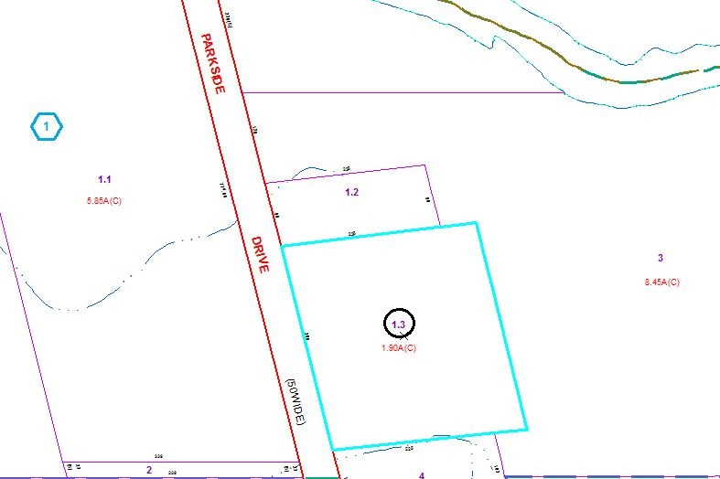

Special Districts for 2015