Parcel 148

9621 Rte. 62, Town of Dayton

|  |  |  |  |  |  |  |  |  |  |  |  |  |  |  |  |
| --- | --- | --- | --- | --- | --- | --- | --- | --- | --- | --- | --- | --- | --- | --- | --- |
| http://maps.cattco.org/imate/quickstream.aspx?file=VOLLOCAL/Rel2017/043089016018000200800000000004.jpg&thumb=true&width=201&height=152 | | | | | | | | **Status:** | | | | Active | | | |
| **Roll Section:** | | | | Taxable | | | |
| **Swis:** | | | | 043089 | | | |
| **Tax Map ID #:** | | | | 16.018-2-8 | | | |
| **Property Class:** | | | | 400 - Commercial | | | |
| **Site:** | | | | COM 1 | | | |
| **In Ag. District:** | | | | No | | | |
| **Site Property Class:** | | | | 400 - Commercial | | | |
| **Zoning Code:** | | | | - | | | |
| **Neighborhood Code:** | | | | 30050 | | | |
| **Total Acreage/Size:** | | | | 0.75 | | | | **School District:** | | | | Gowanda | | | |
| **Land Assessment:** | | | | 2017 - $5,400 | | | | **Total Assessment:** | | | | 2017 - $30,000 | | | |
| **Full Market Value:** | | | | 2017 - $30,000 | | | |  | | | |  | | | |
| **Overall Eff Year Built:** | | | 0 | | | | **Overall Condition:** | | | | Fair | | | |
| **Overall Grade:** | | | Average | | | | **Overall Desirability:** | | | | 2 | | | |
| **AC%** | **Sprinkler%** | **Alarm%** | | | **Elevators** | **Basement Type** | | | **Year Built** | **Condition** | | | **Quality** | **Gross Floor Area (sq. ft.)** | | | **Stories** |
| 0 | 0 | 0 | | | 0 |  | | | 1900 | Normal | | | Average | 3720 | | | 2 |

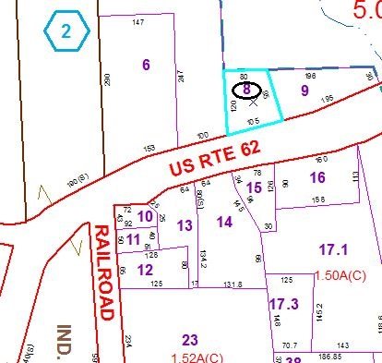

Approximate Yearly Taxes

School $545

Town/County $580

Total $1,125

Special Districts for 2015