Parcel 156

15 Park St, Village of South Dayton

|  |  |  |  |  |  |  |  |  |  |  |  |  |  |  |  |
| --- | --- | --- | --- | --- | --- | --- | --- | --- | --- | --- | --- | --- | --- | --- | --- |
| http://maps.cattco.org/imate/quickstream.aspx?file=VOLLOCAL/Rel2017/043001033033000502800000000005.jpg&thumb=true&width=201&height=152 | | | | | | | | **Status:** | | | | | Active | | |
| **Roll Section:** | | | | | Taxable | | |
| **Swis:** | | | | | 043001 | | |
| **Tax Map ID #:** | | | | | 33.033-5-28 | | |
| **Property Class:** | | | | | 421 - Restaurant | | |
| **Site:** | | | | | COM 1 | | |
| **In Ag. District:** | | | | | No | | |
| **Site Property Class:** | | | | | 421 - Restaurant | | |
| **Zoning Code:** | | | | | - | | |
| **Neighborhood Code:** | | | | | 30080 | | |
| **Total Acreage/Size:** | | | | 58 x 91 | | | | **School District:** | | | | | Pine Valley | | |
| **Land Assessment:** | | | | 2017 - $3,000 | | | | **Total Assessment:** | | | | | 2017 - $77,800 | | |
| **Full Market Value:** | | | | 2017 - $77,800 | | | |  | | | | |  | | |
| **Overall Eff Year Built:** | | | 0 | | | | **Overall Condition:** | | | | Fair | | | |
| **Overall Grade:** | | | Economy | | | | **Overall Desirability:** | | | | 2 | | | |
| **AC%** | **Sprinkler%** | **Alarm%** | | | **Elevators** | **Basement Type** | | | **Year Built** | **Condition** | | **Quality** | | **Gross Floor Area (sqft)** | | | **Stories** |
| 0 | 0 | 0 | | | 0 |  | | | 1930 | Fair | | Average | | 2520 | | | 2 |
| 0 | 0 | 0 | | | 0 |  | | | 1900 | Fair | | Average | | 4680 | | |  |

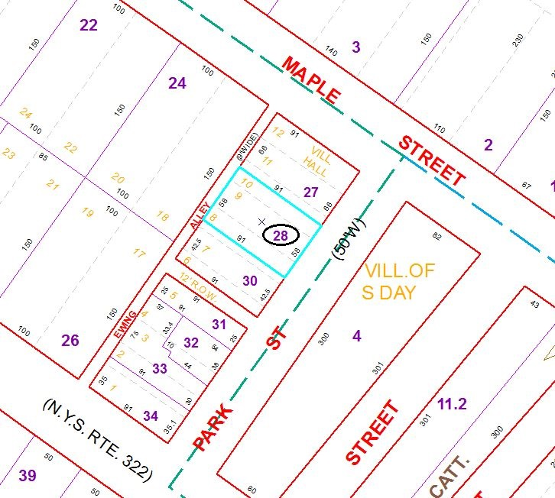

Approximate Yearly Taxes

School $1,719

Village $1,004

Town/County $1,468

Total $4,191

Special Districts for 2015