Parcel 162A

East Flats Rd, Town of East Otto

|  |  |  |  |  |
| --- | --- | --- | --- | --- |
| *NO PHOTO AVAILABLE* | | **Status:** | Active | |
| **Roll Section:** | Taxable | |
| **Swis:** | 043200 | |
| **Tax Map ID #:** | 27.016-1-19 | |
| **Property Class:** | 314 - Rural vac<10 | |
| **Site:** | RES 1 | |
| **In Ag. District:** | No | |
| **Site Property Class:** | 314 - Rural vac<10 | |
| **Zoning Code:** | - | |
| **Neighborhood Code:** | 32050 | |
| **Total Acreage/Size:** | 120 x 142 | **School District:** | Cattaraugus - Little Valley | |
| **Land Assessment:** | 2017 - $4,700 | **Total Assessment:** | 2017 - $4,700 | |
| **Full Market Value:** | 2017 $4,700 | Approximate Yearly Taxes  School $69  Town/County $104  Total $173 |  |

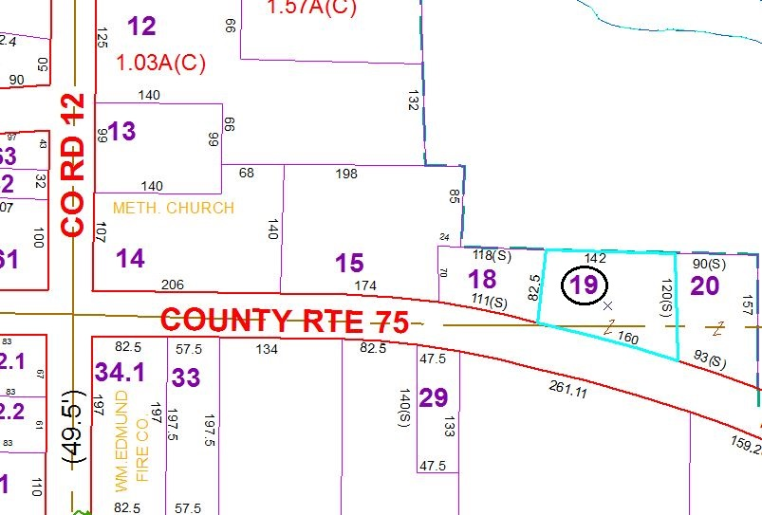

Special Districts for 2015