Parcel 162B

 Plato Rd, Town of East Otto

|  |  |  |  |  |
| --- | --- | --- | --- | --- |
| *NO PHOTO AVAILABLE* | | **Status:** | Active | |
| **Roll Section:** | Taxable | |
| **Swis:** | 043200 | |
| **Tax Map ID #:** | 37.002-1-25.2 | |
| **Property Class:** | 314 - Rural vac<10 | |
| **Site:** | RES 1 | |
| **In Ag. District:** | No | |
| **Site Property Class:** | 314 - Rural vac<10 | |
| **Zoning Code:** | - | |
| **Neighborhood Code:** | 32050 | |
| **Total Acreage/Size:** | 50 x 25 | **School District:** | West Valley | |
| **Land Assessment:** | 2017 - $100 | **Total Assessment:** | 2017 - $100 | |
| **Full Market Value:** | 2017 - $100 |  | Approximate Yearly Taxes  School $2  Town/County $2  Total $4 |

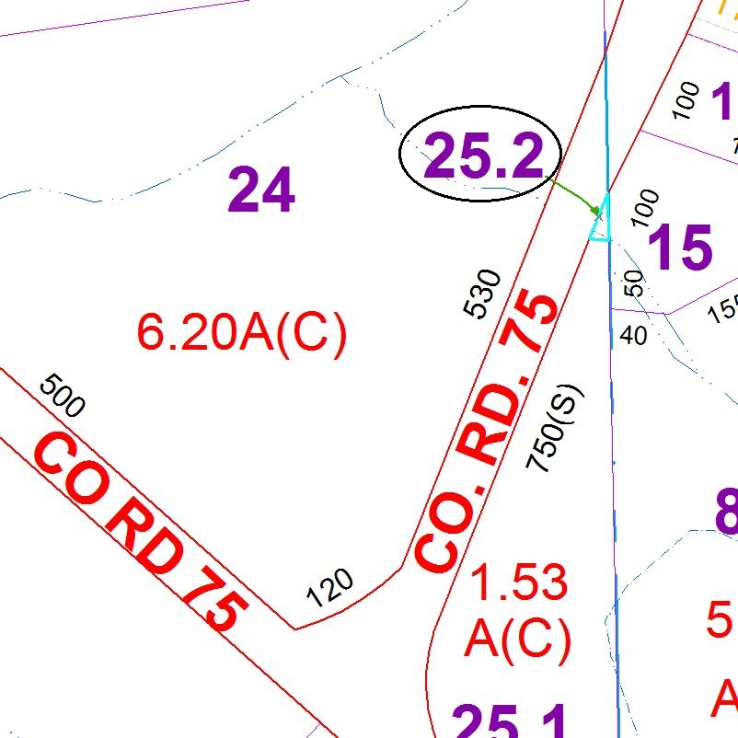

Special Districts for 2015