Parcel 185

5 Mill St, Village of Franklinville

|  |  |  |  |  |  |  |  |  |  |  |  |
| --- | --- | --- | --- | --- | --- | --- | --- | --- | --- | --- | --- |
| http://maps.cattco.org/imate/quickstream.aspx?file=VOLLOCAL/Rel2017/044001040070000401600000000005.jpg&thumb=true&width=201&height=152 | | | | | | **Status:** | | Active | | | |
| **Roll Section:** | | Taxable | | | |
| **Swis:** | | 044001 | | | |
| **Tax Map ID #:** | | 40.070-4-16 | | | |
| **Property Class:** | | 210 - 1 Family Res | | | |
| **Site:** | | RES 1 | | | |
| **In Ag. District:** | | No | | | |
| **Site Property Class:** | | 210 - 1 Family Res | | | |
| **Zoning Code:** | | - | | | |
| **Neighborhood Code:** | | 40150 | | | |
| **Total Acreage/Size:** | | | 72.6 x 267 | | | **School District:** | | Franklinville | | | |
| **Land Assessment:** | | | 2017 - $6,700 | | | **Total Assessment:** | | 2017 - $37,000 | | | |
| **Full Market Value:** | | | 2017 - $55,224 | | |  | |  | | | |
| **Living Area:** | | 1,888 sq. ft. | | | **First Story Area:** | | | | 944 sq. ft. | |
| **Second Story Area:** | | 944 sq. ft. | | | **Half Story Area:** | | | | 0 sq. ft. | |
| **Finished Basement:** | | 0 sq. ft. | | | **Number of Stories:** | | | | 2 | |
| **Building Style:** | | Old style | | | **Bathrooms (Full - Half):** | | | | 1 - 0 | |
| **Bedrooms:** | | 4 | | | **Kitchens:** | | | | 1 | |
| **Fireplaces:** | | 0 | | | **Basement Type:** | | | | Partial | |
| **Porch Type:** | | Porch-covered | | | **Porch Area:** | | | | 96.00 | |
| **Overall Condition:** | | Fair | | | **Overall Grade:** | | | | Average | |
| **Year Built:** | | 1895 | | |  | | | |  | |
| **Structure** | **Size** | | | **Grade** | | | **Condition** | | **Year** |
| Shed-machine | 7 × 11 | | | Economy | | | Fair | | 1990 |
| Shed-machine | 8 × 14 | | | Economy | | | Fair | | 1920 |
| Porch-covered | 6 × 16 | | | Average | | | Normal | | 1992 |
| Shed-machine | 15 × 22 | | | Economy | | | Fair | | 1920 |

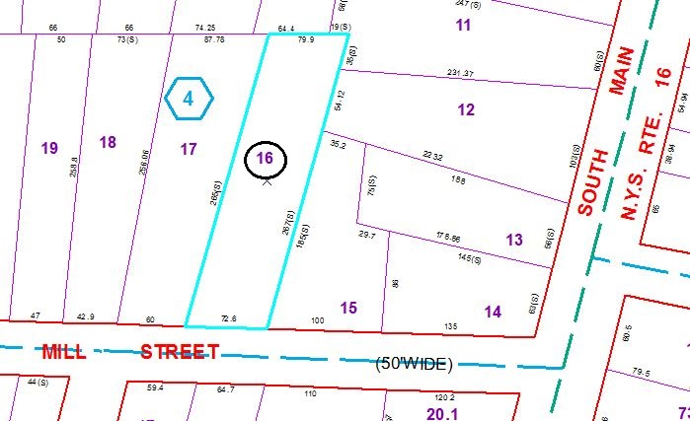

Approximate Yearly Taxes

School $974

Village $479

Town/County $1,086

Total $2,539

Special Districts for 2015