Parcel 210

11233 Scotch Rd, Town of Freedom

|  |  |  |  |  |  |  |  |  |  |
| --- | --- | --- | --- | --- | --- | --- | --- | --- | --- |
| http://maps.cattco.org/imate/quickstream.aspx?file=VOLLOCAL/Rel2017/044200014002000203700100000007.jpg&thumb=true&width=201&height=152 | | | | **Status:** | | Active | | | |
| **Roll Section:** | | Taxable | | | |
| **Swis:** | | 044200 | | | |
| **Tax Map ID #:** | | 14.002-2-37.1 | | | |
| **Property Class:** | | 270 – Mfg. housing | | | |
| **Site:** | | RES 1 | | | |
| **In Ag. District:** | | No | | | |
| **Site Property Class:** | | 270 – Mfg. housing | | | |
| **Zoning Code:** | | 01 | | | |
| **Neighborhood Code:** | | 04200 - Freedom | | | |
| **Total Acreage/Size:** | 1.60 | | | **School District:** | | Yorkshire-Pioneer | | | |
| **Land Assessment:** | 2017 - $9,000 | | | **Total Assessment:** | | 2017 - $37,300 | | | |
| **Full Market Value:** | 2017 - $37,300 | | |  | |  | | |
| **Porch Type:** | Porch-open/deck | | | **Porch Area:** | | 16.00 | | |
| **Structure** | | **Size** | **Grade** | | **Condition** | | **Year** |
| Mobile home | | 76 × 14 | Good | | Normal | | 2000 |
| Porch-open/deck | | 4 × 4 | Good | | Normal | | 2004 |
| Porch-open/deck | | 6 × 3 | Excellent | | Normal | | 2004 |

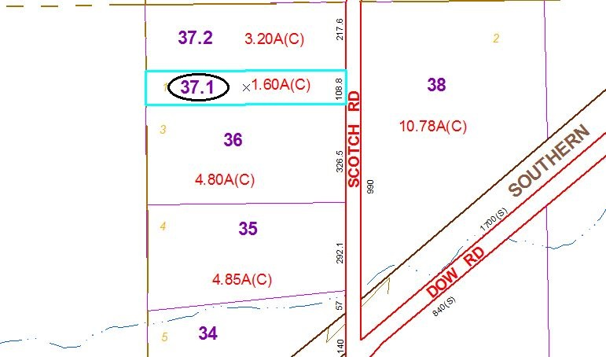

Approximate Yearly Taxes

School $503

Town/County $657

Total $1,160

Special Districts for 2015