Parcel 242

Union Hill Rd, Town of Ischua

|  |  |  |  |  |  |  |  |  |  |  |
| --- | --- | --- | --- | --- | --- | --- | --- | --- | --- | --- |
|  | | | | **Status:** | | | Active | | | |
| **Roll Section:** | | | Taxable | | | |
| **Swis:** | | | 045000 | | | |
| **Tax Map ID #:** | | | 68.003-1-9.3 | | | |
| **Property Class:** | | | 260 - Seasonal res | | | |
| **Site:** | | | RES 1 | | | |
| **In Ag. District:** | | | No | | | |
| **Site Property Class:** | | | 260 - Seasonal res | | | |
| **Zoning Code:** | | | 01 | | | |
| **Neighborhood Code:** | | | 50050 - Town | | | |
| **Total Acreage/Size:** | | 9.41 | | **School District:** | | | Hinsdale | | | |
| **Land Assessment:** | | 2017 - $11,500 | | **Total Assessment:** | | | 2017 - $55,300 | | | |
| **Full Market Value:** | | 2017 - $62,841 | |  | |  | | | |
| **Living Area:** | | 1,152 sq. ft. | | **First Story Area:** | | | 768 sq. ft. | | |
| **Second Story Area:** | | 0 sq. ft. | | **Half Story Area:** | | | 384 sq. ft. | | |
| **Finished Basement:** | | 0 sq. ft. | | **Number of Stories:** | | | 1.5 | | |
| **Building Style:** | | Cottage | | **Bathrooms (Full - Half):** | | | 1 - 0 | | |
| **Bedrooms:** | | 2 | | **Kitchens:** | | | 1 | | |
| **Fireplaces:** | | 1 | | **Basement Type:** | | | Slab/pier | | |
| **Porch Type:** | | Porch-covered | | **Porch Area:** | | | 192.00 | | |
| **Overall Condition:** | | Normal | | **Overall Grade:** | | | Average | | |
| **Year Built:** | | 1991 | |  | |  | | | |
| **Structure** | **Size** | | **Grade** | | **Condition** | | | **Year** |
| Porch-covered | 192.00 sq. ft. | | Average | | Normal | | | 1991 |

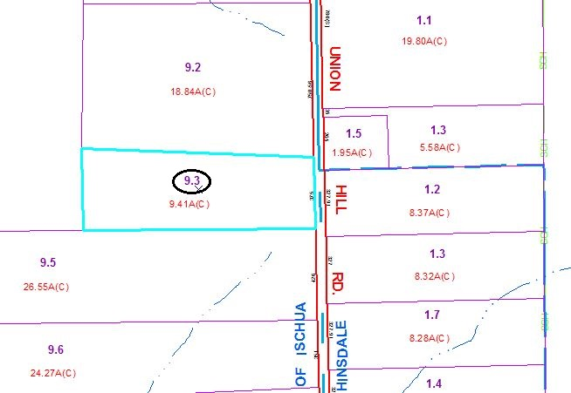

Approximate Yearly Taxes

School $561

Town/County $1,215

Total $1,776

Special Districts for 2015