Parcel 260

Slab City Rd, Town of Lyndon

|  |  |  |  |  |
| --- | --- | --- | --- | --- |
| *No Photo Available* | | **Status:** | Active | |
| **Roll Section:** | Taxable | |
| **Swis:** | 045600 | |
| **Tax Map ID #:** | 50.003-1-24 | |
| **Property Class:** | 314 - Rural vac<10 | |
| **Site:** | RES 1 | |
| **In Ag. District:** | No | |
| **Site Property Class:** | 314 - Rural vac<10 | |
| **Zoning Code:** | 01 | |
| **Neighborhood Code:** | 56350 | |
| **Total Acreage/Size:** | 5.00 | **School District:** | Franklinville | |
| **Land Assessment:** | 2017 - $7,500 | **Total Assessment:** | 2017 - $7,500 | |
| **Full Market Value:** | 2017 - $7,732 | Approximate Yearly Taxes  School $139  Town/County $148  Total $287 |  |

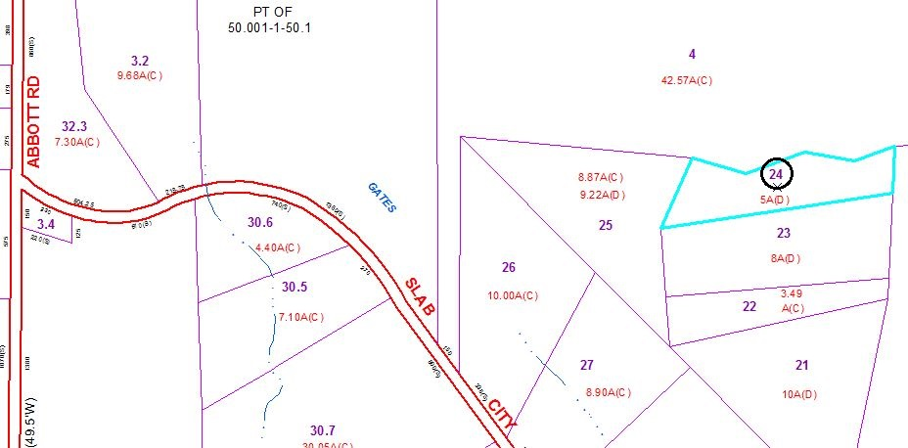

Special Districts for 2015