Parcel 277

 6010 Toad Hollow Rd, Town of Mansfield

|  |  |  |  |  |  |  |  |  |  |  |  |  |
| --- | --- | --- | --- | --- | --- | --- | --- | --- | --- | --- | --- | --- |
|  | | | | **Status:** | | | Active | | | | | |
| **Roll Section:** | | | | Taxable | | | | | |
| **Swis:** | | | | 046000 | | | | | |
| **Tax Map ID #:** | | | | 54.001-3-14 | | | | | |
| **Property Class:** | | | | 210- Single Fam. Res | | | | | |
| **Site:** | | | | RES 1 | | | | | |
| **In Ag. District:** | | | | No | | | | | |
| **Site Property Class:** | | | | 210- Single Fam. Res | | | | | |
| **Zoning Code:** | | | | - | | | | | |
| **Neighborhood Code:** | | | | 60050 | | | | | |
| **Total Acreage/Size:** | | 1.19 | | **School District:** | | | | Cattaraugus - Little Valley | | | | | |
| **Land Assessment:** | | 2017 - $10,300 | | **Total Assessment:** | | | | 2017 - $10,300 | | | | | |
| **Full Market Value:** | | 2017 - $10,300 | |  | | |  | | | |
| **Living Area:** | | 1,400 sq. ft. | | **First Story Area:** | | | | | 850 sq. ft. | | |
| **Second Story Area:** | | 550 sq. ft. | | **Half Story Area:** | | | | | 0 sq. ft. | | |
| **Finished Basement:** | | 0 sq. ft. | | **Number of Stories:** | | | | | 2 | | |
| **Building Style:** | | Old style | | **Bathrooms (Full - Half):** | | | | | 1 - 1 | | |
| **Bedrooms:** | | 4 | | **Kitchens:** | | | | | 1 | | |
| **Fireplaces:** | | 0 | | **Basement Type:** | | | | | Full | | |
| **Porch Type:** | | Porch-covered | | **Porch Area:** | | | | | 60.00 | | |
| **Overall Condition:** | | Fair | | **Overall Grade:** | | | | | Average | | |
| **Year Built:** | | 1915 | |  | | |  | | | |
| **Structure** | **Size** | | **Grade** | | **Condition** | **Year** | | | |
| Barn-1.5 gen | 18 × 34 | | Economy | | Fair | 1960 | | | |
| Gar-1.0 detached | 20 × 24 | | Economy | | Fair | 1940 | | | |
| Porch-covered | 60.00 sq. ft. | | Average | | Normal | 1915 | | | |
| Porch-enclosed | 10 × 20  **HOUSE CONDEMNED** | | Average | | Normal | 1900 | | | |

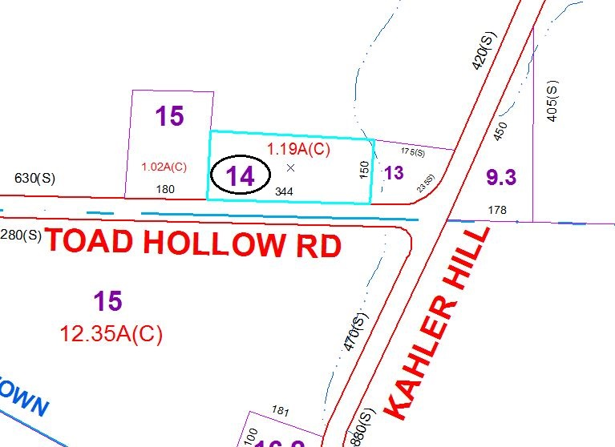

Approximate Yearly Taxes

School $151

Town/County $205

Total $356

Special Districts for 2015