Parcel 320A

W River Rd, Town of Olean

|  |  |  |  |  |
| --- | --- | --- | --- | --- |
| *No Photo Available* | | **Status:** | Active | |
| **Roll Section:** | Taxable | |
| **Swis:** | 046600 | |
| **Tax Map ID #:** | 94.003-4-28 | |
| **Property Class:** | 315 - Underwater land | |
| **Site:** | RES 1 | |
| **In Ag. District:** | No | |
| **Site Property Class:** | 315 - Underwater land | |
| **Zoning Code:** | - | |
| **Neighborhood Code:** | 66350 | |
| **Total Acreage/Size:** | 400 x 50 | **School District:** | Olean | |
| **Land Assessment:** | 2017 - $100 | **Total Assessment:** | 2017 - $100 | |
| **Full Market Value:** | 2017 - $130 | Approximate Yearly Taxes  School $4  Town/County $2  Total $6 |  |

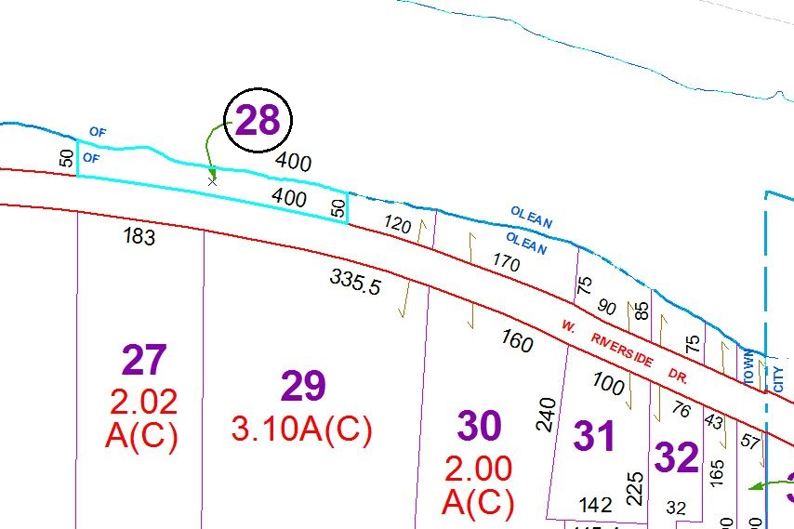

Special Districts for 2015