Parcel 330

12353 Planck Rd, Town of Perrysburg

|  |  |  |  |  |  |  |  |  |  |  |  |  |
| --- | --- | --- | --- | --- | --- | --- | --- | --- | --- | --- | --- | --- |
| http://maps.cattco.org/imate/quickstream.aspx?file=VOLLOCAL/Rel2017/047000007002000101300000000003.jpg&thumb=true&width=201&height=152 | | | | | **Status:** | | | | Active | | | |
| **Roll Section:** | | | | Taxable | | | |
| **Swis:** | | | | 047000 | | | |
| **Tax Map ID #:** | | | | 7.002-1-13 | | | |
| **Property Class:** | | | | 210 - 1 Family Res | | | |
| **Site:** | | | | RES 1 | | | |
| **In Ag. District:** | | | | No | | | |
| **Site Property Class:** | | | | 210 - 1 Family Res | | | |
| **Zoning Code:** | | | | - | | | |
| **Neighborhood Code:** | | | | 70350 | | | |
| **Total Acreage/Size:** | | | 5.89 | | **School District:** | | | | Gowanda | | | |
| **Land Assessment:** | | | 2017 - $11,800 | | **Total Assessment:** | | | | 2017 - $83,800 | | | |
| **Full Market Value:** | | | 2017 - $126,970 | |  | | | |  | | | |
| **Living Area:** | | 1,946 sq. ft. | | | **First Story Area:** | | | | | 762 sq. ft. | |
| **Second Story Area:** | | 1,184 sq. ft. | | | **Half Story Area:** | | | | | 0 sq. ft. | |
| **Finished Basement:** | | 0 sq. ft. | | | **Number of Stories:** | | | | | 2 | |
| **Building Style:** | | Contemporary | | | **Bathrooms (Full - Half):** | | | | | 1 - 1 | |
| **Bedrooms:** | | 3 | | | **Kitchens:** | | | | | 1 | |
| **Fireplaces:** | | 0 | | | **Basement Type:** | | | | | Slab/pier | |
| **Porch Type:** | | Porch-enclosed | | | **Porch Area:** | | | | | 96.00 | |
| **Overall Condition:** | | Normal | | | **Overall Grade:** | | | | | Average | |
| **Year Built:** | | 1997 | | |  | | |  | | | |
| **Structure** | **Size** | | | **Grade** | | **Condition** | **Year** | | | |
| Shed-machine | 6 × 12 | | | Economy | | Fair | 1997 | | | |
| Gar-1.0 detached | 24 × 32 | | | Average | | Normal | 1999 | | | |
| Porch-enclosed | 4 × 24 | | | Average | | Normal | 1997 | | | |

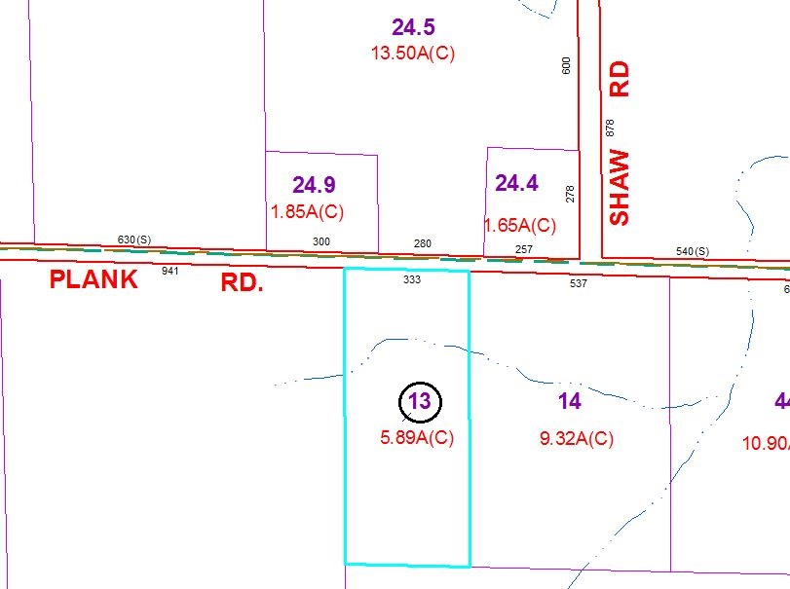

Approximate Yearly Taxes

School $2,145

Town/County $2,264

Total $4,409

Special Districts for 2015