Parcel 65

309 Second St S, City of Olean

|  |  |  |  |  |  |  |  |  |  |
| --- | --- | --- | --- | --- | --- | --- | --- | --- | --- |
| http://maps.cattco.org/imate/quickstream.aspx?file=VOLLOCAL/Rel2017/041200094073000304600200000006.jpg&thumb=true&width=201&height=152 | | | | **Status:** | | Active | | | |
| **Roll Section:** | | Taxable | | | |
| **Swis:** | | 041200 | | | |
| **Tax Map ID #:** | | 94.073-3-46.2 | | | |
| **Property Class:** | | 312 - Vac w/improvement | | | |
| **Site:** | | RES 1 | | | |
| **In Ag. District:** | | No | | | |
| **Site Property Class:** | | 312 - Vac w/improvement | | | |
| **Zoning Code:** | | - | | | |
| **Neighborhood Code:** | | 12203 | | | |
| **Total Acreage/Size:** | | 37 x 125 | | **School District:** | | Olean | | | |
| **Land Assessment:** | | 2017 - $3,300 | | **Total Assessment:** | | 2017 - $3,300 | | | |
| **Full Market Value:** | | 2017 -$3,708 | |  | |  |
|  | |  | |  | |  | | |  |  | |
|  | |  | |  | |  | | |  |  | |

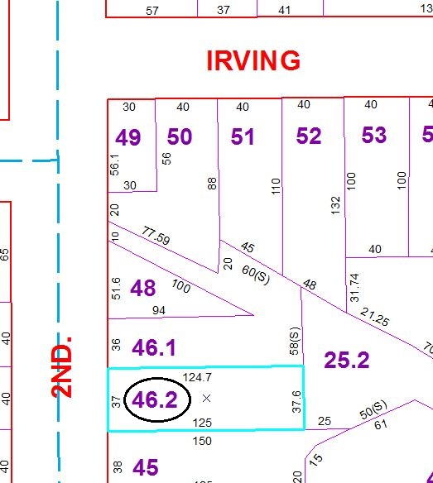

Approximate Yearly Taxes

School $86

City $48

County $47

Total $181

Special Districts for 2015