Parcel 79B

906-R Osgood Ave, City of Olean

|  |  |  |  |
| --- | --- | --- | --- |
| *NO PHOTO AVAILABLE* | | **Status:** | Active |
| **Roll Section:** | Taxable |
| **Swis:** | 041200 |
| **Tax Map ID #:** | 94.075-1-36 |
| **Property Class:** | 311 - Res vac land |
| **Site:** | RES 1 |
| **In Ag. District:** | No |
| **Site Property Class:** | 311 - Res vac land |
| **Zoning Code:** | - |
| **Neighborhood Code:** | 12207 |
| **Total Acreage/Size:** | 2.97 | **School District:** | Olean |
| **Land Assessment:** | 2017 - $20,000 | **Total Assessment:** | 2017 - $20,000 |
| **Full Market Value:**  PARCEL IN PERMANENT  EASEMENT ZONE FOR NYS FLOOD PROJECT | 2017 - $22,472 |  |  |

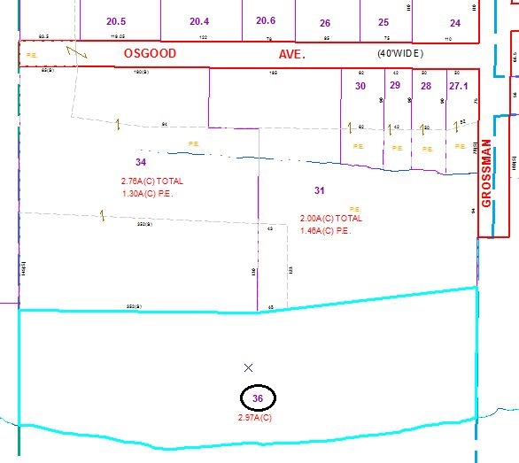

Approximate Yearly Taxes

School $522

City $292

County $280

Total $1,094

Special Districts for 2015